Information for teachers and group leaders visiting the Danny in Liverpool

1. Overview
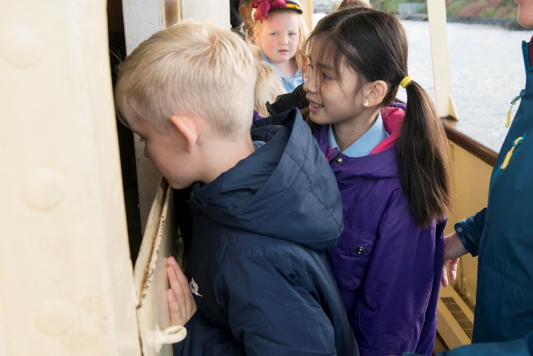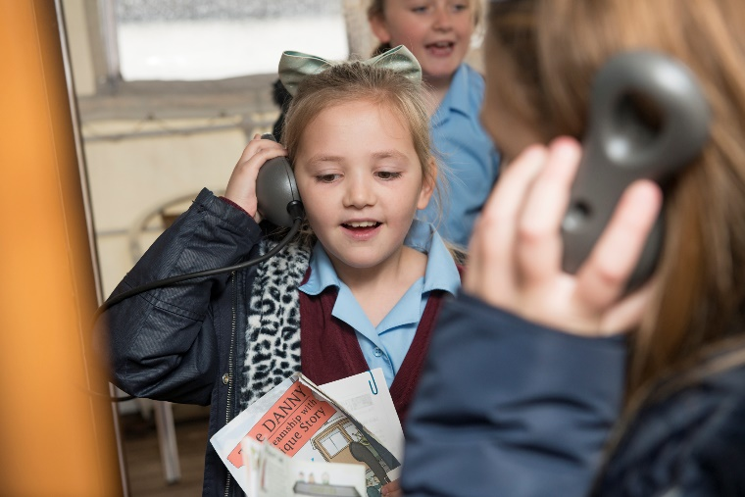
Peeking in at the boiler room while exploring the vessel Finding out about the rescue of the Danny
Location: Canning Dock, Liverpool, L3 4AX (opposite the Merseyside Maritime Museum)
Combined offer with National Museums Liverpool: We have partnered with National Museums Liverpool to link visiting children with workshops and displays at the museum that will deepen and contextualise their learning on the Danny. If you are bringing two classes, one will start with the museum workshop in the morning, while the second group comes to the Danny. After lunch (facilities can be booked at the museum), the groups swap over. We have also kept a number of days where you can book just the Danny workshop – we would still recommend a self-guided visit to the museum on those days, as well as booking cloakroom and lunchroom facilities at the museum.
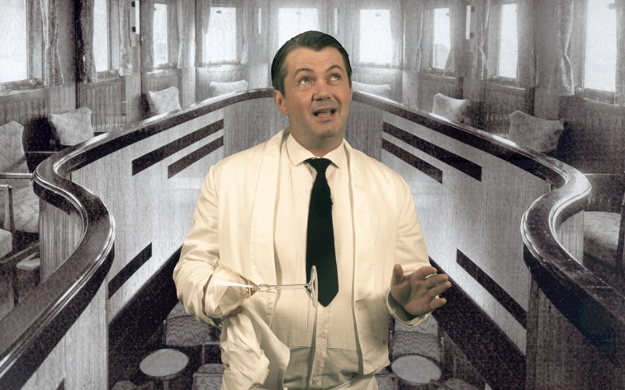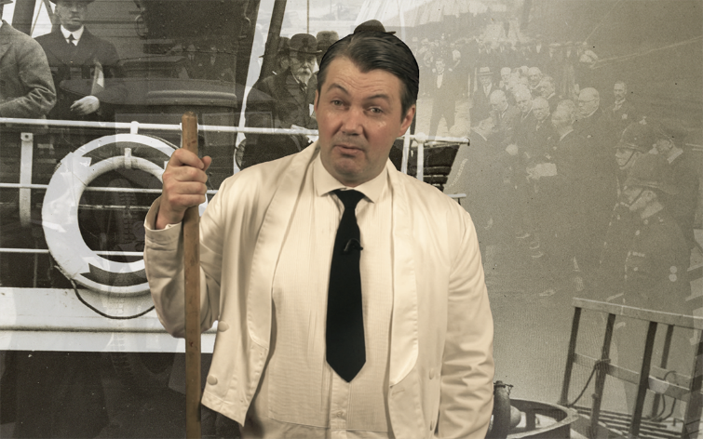
Our 1950s barman describes the installation of the Art Deco saloons and the important visitors entertained there in the Danny’s past
Workshops: £60 per class, based on class of approximately 30 pupils; 90 minutes. Workshop offer aimed at KS2 pupils in history, science and art and design, or KS1 pupils in history, literacy, art and design.
All proceeds from our educational visits go to maintaining The Danny and her education programmes. We are currently in receipt of Lottery Heritage Funding, which subsidises all education activities.
Background: Moored opposite the Merseyside Maritime Museum, the Daniel Adamson is the last operational steam tugboat and passenger tender in the UK. She was built in Birkenhead in 1903 and saved from the scrapyard by local volunteers in 2004. Finally restored to peak condition earlier this year, her history reflects and offers a vantage point from which to explore the history of the region.

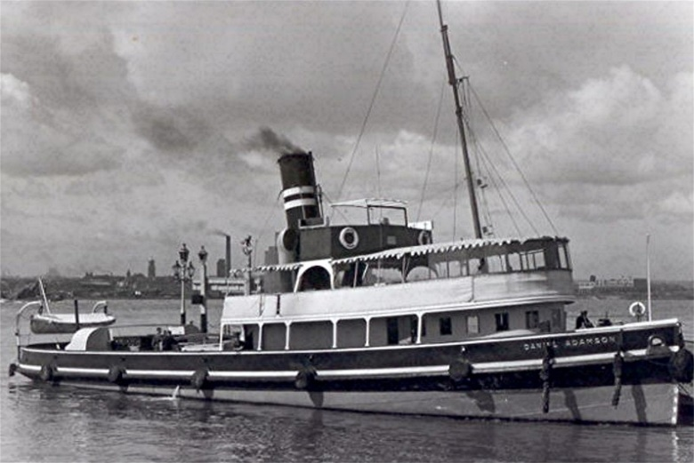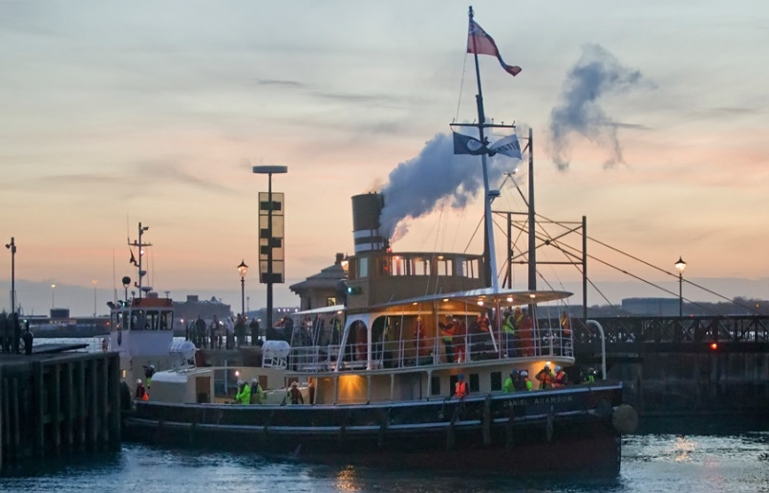
The Danny’s last visit to Liverpool, September 1947 Until arriving back into Canning Dock,newly refurbished, May 2016
From a life of towing river barges and ferrying passengers from Ellesmere Port into the thriving Port of Liverpool, the Danny went on to survive two world wars, and to become the official director’s launch of the Manchester Ship Canal Company, hosting visits from kings, princes, sultans and ambassadors from across the world.
A visit allows children the chance to explore the physical environment of a working vessel, to understand the role such vessels played in the busy port life, and to begin to understand the significance of the waterways and ports in local history. It offers a wonderful opportunity for the children to explore historical continuity and change, cause and consequence, and to come to appreciate the escape the Danny has had from the inexorable forces that rendered its kind obsolete, and saw all steam tug tenders destroyed bar this one, which we are lucky to have on Merseyside.

Workshop dates at Canning Dock, Liverpool:
KS2 Making History (on the Danny) with KS2 All Hands on Deck (at the Maritime Museum)
June 5, 6, 7 & Sept 25, 26, 27
KS2 Making History (on the Danny) with KS2 Gateway to the World (at the Museum of Liverpool)
June 26, 27, 28 & Oct 2, 3, 4
KS1 Shanty on the Danny (on the Danny) with KS1 Transport across time (at the Museum of Liverpool)
July 3, 4, 5
KS1 or KS2 workshops on the Danny only (but can be booked together with a self-guided museum visit at Merseyside Maritime Museum or Museum of Liverpool )
May 3,22,24 & June 12 & July 10,11,12, 17, 19 & Sept 11,12, 13
Access: Unfortunately, The Danny is not wheelchair accessible. When on board, there are steps to negotiate which people with limited mobility may find challenging
2. Booking your visit
All visits must be booked a minimum of two weeks in advance. Please email a completed booking form to learning@danieladamson.co.uk. If you have indicated that you wish to take up the offer of a joint learning programme with our partners at National Museums Liverpool, we will forward the booking form to them, and they will get back to you to confirm the booking.
We would be very happy to accommodate a teacher’s visit to the vessel in advance. If you are bringing Key Stage 2 children, we would like to know in advance whether you wish them to have access to the engine and boiler rooms (we recommend that there not be access for children younger than year 5, but this decision is at the teacher’s discretion – see risk assessment at the end of the document).
If you have any queries, please contact learning@danieladamson.co.uk or call 07575 197771. If you have queries for our museum partners at National Museums Liverpool, please call 0151 478 4788.

3. On the day of your visit
Parking: Coaches should drop off and pick up your group outside the former Dock Traffic Office/Granada Studios. Parking is available at Kings Dock. Pay-and-display parking for cars is available opposite the Dock Traffic Office and at Kings Dock.
Arrival: When you enter the museum foyer at 10.00, please sign in at the Information Desk of the Merseyside Maritime Museum or the Museum of Liverpool (depending on which sessions or visits you have booked) with your booking confirmation for both the museum and for the Danny. Please ensure you arrive on time to allow for toilet visits etc. so that you can begin your session on time. Be aware that if you arrive late we may need to curtail the session.
A member of the Danny learning team will meet you at 10.00 at the information desk to escort you to the Danny and to brief your group on key safety information, and on the organisation of the session before boarding. (If there are two classes, one will come to the Danny, the other will do the museum workshop or visit).
Access: The Danny is moored at Canning Half Tide Dock, in front of the Merseyside Maritime Museum. Access is via the gangway. Unfortunately, The Danny is not wheelchair accessible. When on board, there are steps to negotiate which people with limited mobility may find challenging.
Toilets: There are toilets and wheelchair accessible toilets on all floors at the Merseyside Maritime Museum. Toilets on board The Danny are only for emergency use.
Cloakroom: There is no cloakroom in the museum or on board the Danny. You can book storage for coats, etc. in the nearby cooperage building in advance when you book your visit to the Merseyside Maritime Museum.
Group lunchroom: Accommodation for eating packed lunches is available from Merseyside Maritime Museum in the nearby cooperage building. This facility is allocated according to a timetable and must be booked in advance. Packed lunches can be taken to the lunchroom on arrival and left there until lunchtime.
Photography: You are allowed to take photos everywhere on board the Danny. We would also like to document the workshops, and will ask if we may send you image release forms upon booking.

Example itinerary for a school group with two classes visiting both the Danny and one of the museums (Museum of Liverpool or Merseyside Maritime Museum):
Group A: 10.15-11.15 Museum Workshop
Group B: 10.15-11.45 Danny workshop
Group A: 11.15 – 12.45 LUNCH and free time
Group B: 11.45 – 13.15 LUNCH and free time
Group A: 12.45 – 14.15: Danny workshop
Group B: 13.15 – 14.15: Museum workshop
2.30 All children ready at museum foyer to get coach back to school

4. On board the Danny
Once we have met the group at the museum, and they have disposed of bags, visited toilets, etc, where possible, we bring them on board the Danny. After a brief introduction with health and safety information and briefing, we will divide the class into two groups: one will initially explore the Art Deco saloons, and the other will initially explore the vessel and identify her historic significance.
Please bring the minimum of personal belongings, coats, bags, etc onto the vessel, and take care not to block any circulation routes or fire exits and be aware that we may have to impose restrictions at busy times.

5. Emergency procedures:
Emergency alarm – seven short blasts of the ship’s horn and public address announcements
• Lead your group quickly and quietly to the prom deck gangway. The Danny’s team will direct you.
• Do not stop to collect belongings.
• Lead your group down the gangway to the quayside. Avoid approaching fire engines.
• Do not re-enter the vessel for any reason.
• Staff will advise you when it is safe to return.

6. Risk Assessment and legal stuff
While those in charge of groups visiting the Danny take ultimate responsibility for the health and safety of their groups, we recognise our legal obligations to provide a healthy and safe environment for all visitors. We also have in place:
• Codes of practice for procedures dealing with emergencies, first aid, incidents and accidents.
• Public liability insurance. Full details are available.
• A policy for the safeguarding of children, young people and vulnerable adults.
We have prepared the following risk assessment for the building your staff and children are visiting. Below is our assessment of risks for groups visiting the Danny:
 |  | (S x L = Risk) |  |  |  |  |  |  |  |  | ASSESSED BY  Print name: Cathriona Bourke  Date: 19/07/2016  REVIEWED BY  Print name: Andrea Ward  Date: 07/08/2016
HAZARDOUS  ACTIVITY | RISK BEING ASSESSED | SEVERITY  FATAL /MAJOR = 3  Loss / Disability = 2  Minor / Illness = 1 |  |  | LIKELIHOOD  Certain / Very = 3  Reasonably = 2  Seldom/unlikely = 1 |  |  | LEVEL OF RISK  6-9 = High (H)  4 = Medium (M)  1-3 =Low (L) |  |  | Is risk adequately controlled? | What further action can be taken to control the risk? | Residual Risk following implementation of Control Measure
 |  | 1 | 2 | 3 | 1 | 2 | 3 | L | M | H |  |  | L | M | H

Boarding the vessel | Trips, slips |  |  | X | X |  |  | X |  |  | 1. Deck crew to ensure gangway is secure before opening  2. Groups briefed on safe method of walking up the gangway |  | X
Exploring the upper prom deck | Trips, slips, bumping against heavy resources |  |  | X | X |  |  | X |  |  | Groups briefed on safe negotiation of the companionway; on walking, not running; and briefed to stow their possessions to avoid trip hazards, to follow instructions on working with resources and not to touch/enter cordoned off areas. |  | X
Walking on the main decks | Trips, slips, falling overboard |  |  | X | X |  |  | X |  |  | Groups briefed to walk carefully, especially if the decks are wet, and not to sit on the bulwarks. |  | X
Accessing the upper and lower saloons | Trips, falling down trapdoors |  |  | X | X |  |  | X |  |  | Crew check all trapdoors are shut before opening to the public |  | X
Accessing the engine and boiler room | 1. Falls,  2. bumps to head  3. burns,  4. chemicals  5. secluded area  6. allergy to coal dust |  |  | X |  | X |  |  | X |  | 1. Volunteer to oversee ladder.  2. PPE to be worn, 6 pupils max.  3. All furnace doors shut; guardrails in place  5. Chemicals locked away  5. All volunteers have DBS, sole volunteer never alone with pupils | 1. Engine room visits not available for younger than year 5.  2. Teacher to decide in advance if his/her pupils are to have engine room visit | X
Standing/moving around static vessel | Falls or trips due to vessel rolling as water levels rise |  |  | X | X |  |  | X |  |  | 1. visitors briefed on safely going up/down stairs on board.  2. Harbourmaster shares information & crew respond

